Jonesport Wood Co., Inc.
www.jonesport-wood.com Email: jwood@jonesport-wood.com
The Tool Barn
17 Breakneck Rd, PO Box 144
HULLS COVE, ME 04644-0144
207/288-5126 Fax: 207/288-2725
Captain Tinkham’s Emporium Liberty Tool Co.
34 Main St, PO Box 321 57 Main St, PO Box 346
SEARSPORT, ME 04974 LIBERTY, ME 04949
207/323-9632 207/589-4771

April 28, 2016

To: All Coastal Maine Commercial Real Estate Brokers

The Jonesport Wood Company, Inc. has been in the used tool and antique business since 1970. We opened our store in Liberty, Maine in 1976, and Captain Tinkham’s Emporium in Searsport in 1996. In 1999, we opened the Davistown Museum, which is the largest edge tool museum in the US. Liberty Tool Company is now considered the largest single owner used tool store in New England.

My objective as an aging tool picker is to sell my Searsport property, which includes a very large inventory, three small store fronts, a first floor workshop – eBay sales area, and two apartments on the second and third floors, which share a washer/dryer. The rental income from the apartments is currently $1,350/month. My firm sales price is $325,000 for the building and business.

I would certainly like to hear from any interested brokers that may have a customer with an interest in selling used and antiquarian tools, antiques, artwork, old books, and/or in an eBay sales location.

Earlier in the month, Jaret & Cohn visited and indicated they were interested in handling the sale. A week later they called me back and indicated it was too difficult to evaluate the value of the business and that Searsport’s depressed real estate values makes properties in Searsport extremely difficult to sell.

Nonetheless, we have had a long established and very successful business at that location. Initially, when we were open all summer and with extensive spring and fall hours, we were selling in the ±$75,000/year. Currently, all our eStore sales are executed by Sett at the Davistown Museum location in Liberty where annual sales are 75,000-90,000 dollars. Sett only works part time on the eStore, and it is my opinion that a buyer of the Searsport property that is experienced at his trade, could exceed those online sales by utilizing the two back rooms. Currently we are only open in Searsport on Saturdays, but it has been a busy winter and we have hundreds of regular customers, many of which (but not all) patronize all 3 stores. I am puzzled by the fact that our well known and long established business with its very extensive inventory (see photo tour) would be of no interest to commercial real estate brokers of the area.
In case one of the recipients of this memo has a customer with an interest in the antiquarian and historical please give me a ring. The building is on the National Register of Historical Buildings. It was built in 1820 for the Parker family of sea captains and is located on US Rte 1 next to the Penobscot Maritime Museum.

I would like to note that I am skeptical of the suggestion that the property (it is in good condition) has value only as an empty building. Please note that as long as I am an active tool picker for the Jonesport Wood Company, we can supply substantial amounts of inventory to a buyer and can offer discounts at all stores ranging from 20% (except woodworking edge tools) to as much as 40% for lower valued inventory. Any comments or suggestions would be welcome.

Don’t forget to visit our various websites and take a photo tour of all our properties.
www.captaintinkhams.com
www.jonesport-wood.com/captaintink.html
www.jonesport-wood.com/jwRealEstateStoreListing.html
www.libertytoolco.com
stores.ebay.com/libertytoolco
www.etsy.com/teams/11378/jonesport-wood-company/
www.facebook.com/libertytool
www.pinterest.com/libertytool/
www.davistownmuseum.org

Yours truly,
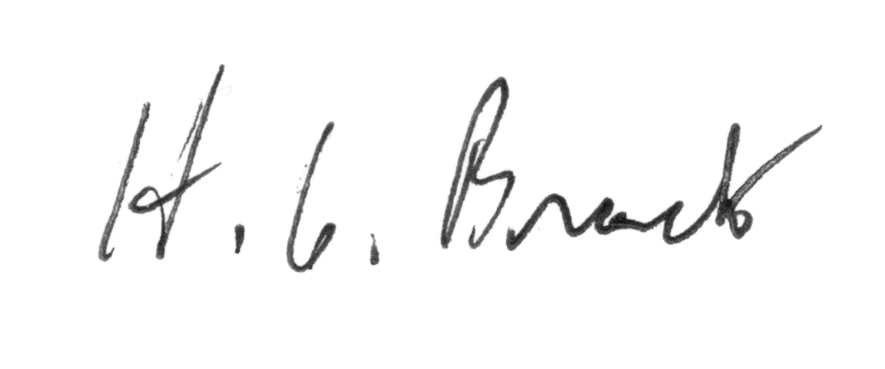
H. G. Brack

